Diary entry for 9th October

1.1 Introduction

According to the brief given, the game needed to be about territorial acquisition with mechanics that supported conquering enemy territory, engage in alliances and trade.

It was decided that a board game was the best option to present the game. Apart from the board game itself, other materials such as coloured cards for each player and dice for the conquering mechanic were needed. Pen and paper were also recommended because players needed to keep track of the amount of turns that have passed since the game began.

1.2 Rules

The rules of the game were as follows:

* Players were only allowed to move a maximum of 3 tiles.
* Players could only move either in a straight line or an L shape.
* When conquering a tile, both players must roll their dice to determine whether the tile is conquered or kept.
* The player with the largest number in their collection of dice was deemed the winner of the competing process.
* The player with the most tiles conquered was deemed the winner after 10 turns.

At the start of the game, all players needed to roll a single die and whichever gained the highest number became the first to move in any direction so long as it was in accordance with rules of the game.

When conquering a tile that already belonged to an enemy, each player would roll a collection of dice similar to the start of the game and the player with the highest number was deemed the winner. How many dice players needed to roll was dependent on the number of tiles directly touching the tile of the defending player. For example: if the player that was attacking had two of their own tiles touching the tile they wished to conquer then they would roll a pair of dice. This rule also applied to defending, so long as the defending tile had one or more of its own coloured tiles touching it then the defending player could roll multiple dice.

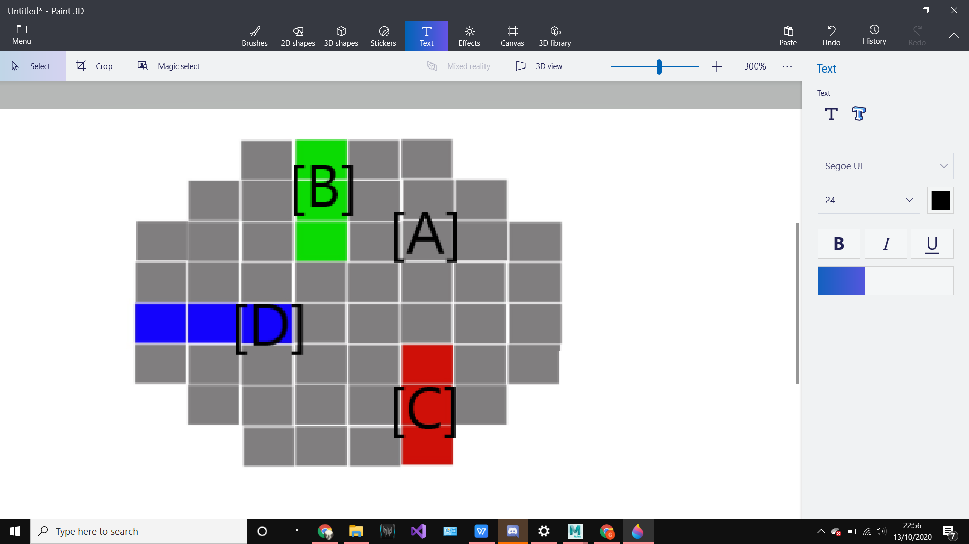

Figure 1. Prototype Gameboard. The gameboard[A] stays as grey unless any of the players [B][C][D] occupy a space.

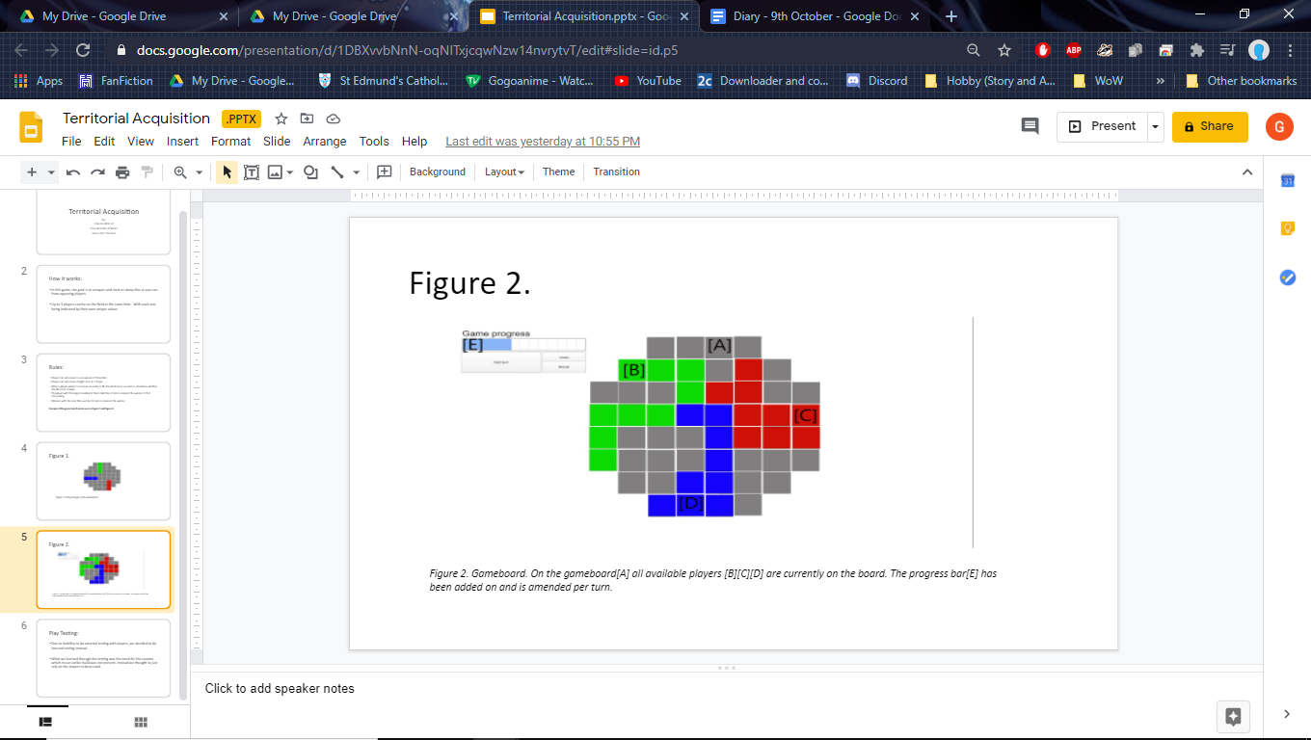

Figure 2. Final Gameboard. The scene shows the players[B][C][D] now occupying more of the gameboard[A]. Player [D] has conquered a tile hence the break in the line belonging to player[C]. A universal counter [E] has also been added to keep track of turns.

1.3 Reflection

Although no external play testing was done, internal play testing showed that keeping track of turns was difficult. Using this discovery, the game was given a turn counter to keep track of the turns for the players.

In this game, roles were given to everyone which split the job resulting in everyone working efficiently. These roles consisted of one working on the compilation of the development process in a presentation, another making the game itself and the last feeding everyone the necessary information. With one being the actual creator while the guide told the creator on how the mechanics should work in gameplay, while also feeding the same information to the one compiling the presentation. By having these roles, the first prototype came out close to what was envisioned.

As for personal performance, there was an improvement in communicating and this was due to the fact that there were less people in the team, which made projecting ideas easier and resulted in the game’s premise being agreed upon earlier. However when it came to presenting the game, eye contact was not on the audience and the volume of my voice was too low to be heard, these need to be improved upon since it can lead to the audience feeling alienated from the presentation.